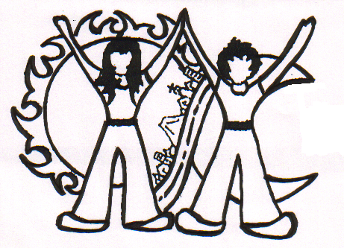Movimiento de Jóvenes de la Calle – MOJOCA
13 calle 2-41. Zona 1, Guatemala, Guatemala. Cp. 01001
 22327425 - 22519237 Email: mojocalle@gmail.com

OPEN LETTER TO THE PRESIDENT AND VICE-PRESIDENT OF GUATEMALA

Guatemala, 2nd December 2011

Elected President
General Otto Pérez Molina

Elected Vice-President
Licda. Roxana Baldetti
We, the boys and girls of the Association Street Youngsters Movement (Asociación Movimiento de Jóvenes de la Calle, MOJOCA) respectfully greet to you.

On the 14th January 2012, you will be inaugurated as President and Vice-President of the Republic of Guatemala and, therefore, also as our governors and leaders. We wish you a successful government, one that overcomes the illegality and violence that plagues our country, whilst respecting the rights of all Guatemalans.

We, the girls and boys of the street, are victims of this very same violence and delinquency that you have been elected to address. Our rights are not respected, least of all the right to life; many of us have been murdered, tortured and raped. We have no home, no access to education, to health care or to decent jobs. Some of us are not legally citizens, because we do not have birth certificates. We often do not know where we were born, when we were born, or even who our parents are. It is therefore extremely difficult for us to obtain a legal identity. We are poor and excluded Guatemalans who desire a more just and fraternal country wherein all citizens are united by ties of friendship and solidarity.

In 1996, at the General Assembly of street youngsters, made up of the various groups in the capital, we decided to form a movement, one that would be directed by ourselves, but with guidance from responsible adults. This movement would work to defend our rights, to improve our quality of life, to help us enter society and to participate as responsible citizens, as well as to contribute to a more just national and international society.

Since our official foundation in 1999, our non-profit association has enabled hundreds of street girls, boys and children to enter society with dignity. Our association offers basic education programmes, training workshops in our education centre, and study grants for primary to university-level education. Many other initiatives have helped young men and women to leave a life on the streets.

The results that we have achieved have been supported almost entirely by assistance from abroad. We have received some donations from Guatemalan friends including, in 2008, a first place prize of Q500,000 awarded by the Juan Bautista Gutierrez Foundation, in recognition of the excellence of our social work. However, we are largely supported by international and European institutions, which include the European Union, UNESCO, and by various cities, regions and non-governmental associations in Holland, Spain, Belgium and Italy.

We also have links to associations across Latin America and Europe, who follow with interest the work of MOJOCA and the evolving situation faced by the street girls and boys. These associations are particularly interested in and sensitive to the respect for the rights of these young women and men.

Above all, we believe that it would be more just to receive support from within Guatemala, because we the street girls and boys – are children and citizens of this country.

We have already requested support from previous governments to respect our rights, and above all, the right to a home and to a decent job. We believe it is the role of the state to respect the rights of each and every individual living in this country, irrespective of their background and status.

The work of MOJOCA is not easy because lodging is very expensive and it is difficult for us, who generally have low educational levels and who may have tattoos, to find work that allows us to live with dignity. We therefore respectfully ask you, as the incoming government, to provide us, the street girls and boys, with the necessary support to enter into society with dignity.

We would welcome a meeting with one of your collaborators in order to be able to explain our situation, our desires, and our willingness to support the measures to resolve the exclusion of the street boys and girls, peacefully and with respect for human rights.

Equally, we support initiatives to construct a lasting peace in Guatemala, ones that will work to bring us together through justice, equality, a just redistribution of wealth, and respect for the rights of all Guatemalans.

Mr President and Ms Vice-President, we write to you with the hope of a favourable response to our request.

Yours faithfully,

Movement of Street Children
Letter presented by the Management Committee, with unanimous support from the General Assembly of MOJOCA, 2nd December 2011. This letter was approved and signed by 180 participants.

